**Connected Campus Crew**

Mark Girguis, Kishan Patel, Ankit Monga,

Eric Gonzalez, Jason Chung, Hector Khuon

**Deliverable 5**

**IS 436 - 03**

**5/9/19**

**Student Success Dashboard:**

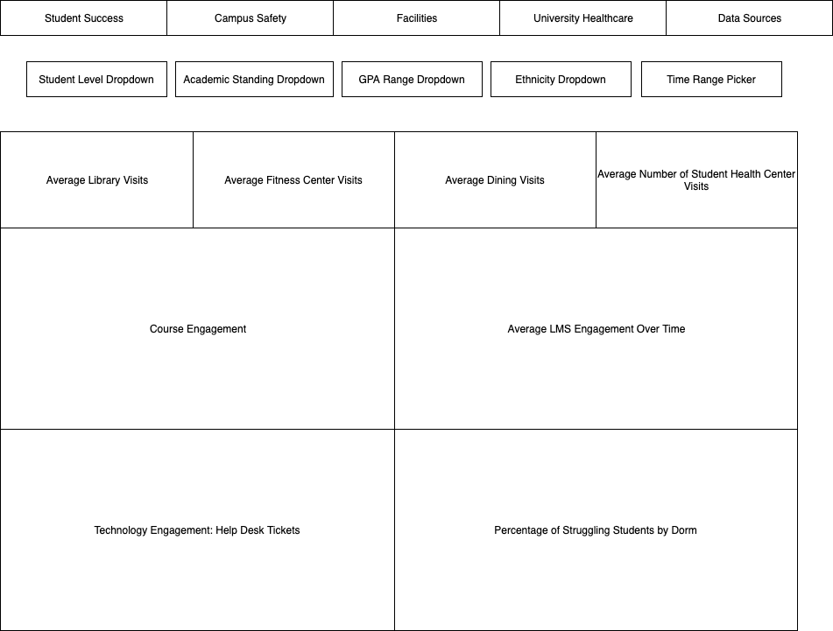

**Facilities**

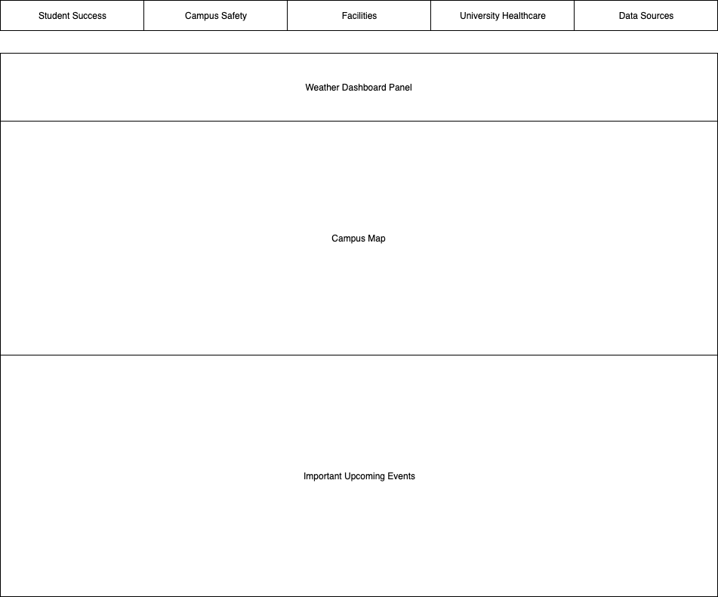

**Student Health Center**

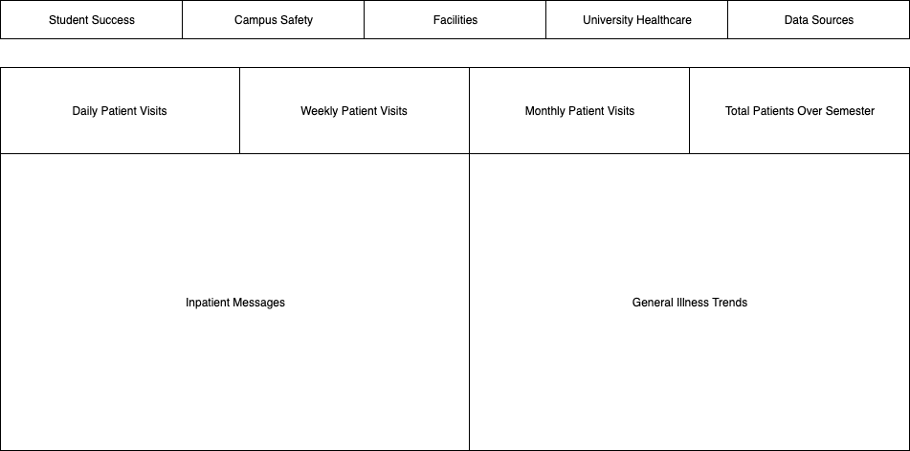

**Principles for User Interface Design**

**Layout**

* **The navigation area and work area are divided into separate boxes**
* **Like areas: Student Success, Campus, Facilities, etc. are grouped for navigation**
* **The work area comprises of user specific information**
* **Layout is consistent and balanced across all pages for easy navigation**

**Content Awareness**

* **Every interface is clearly titled**
* **Menus show what area of site the user is in**
* **Dropdown menus give more specific context**

**Aesthetics**

* **Content is evenly spaced**
* **Font and size is designed for easy readability**

**Consistency**

* **Elements such as navigation bar are consistent throughout the site**